1. **Create user with name Techie and provide Sudo access to user1**

**Esu17**

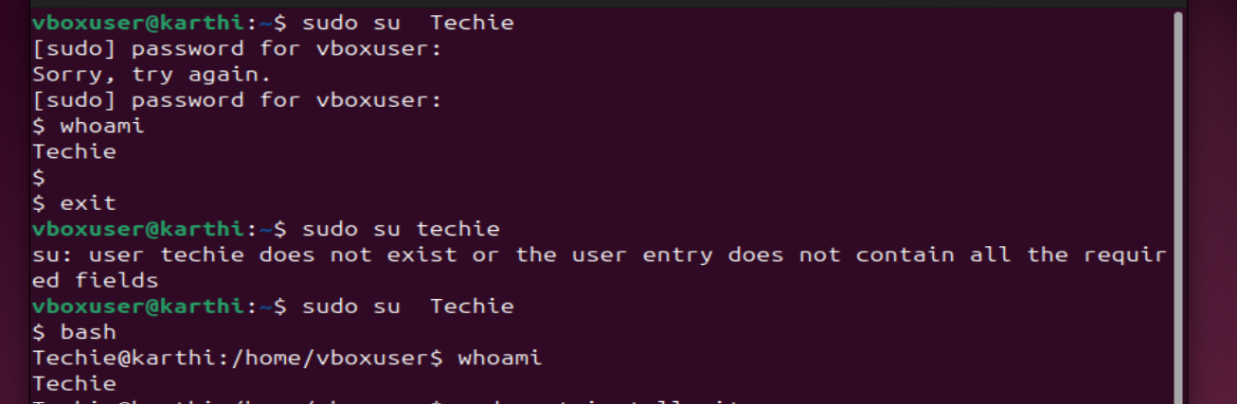

1. **Navigate to the home directory.**



1. **Create a new directory.**



1. **List of directory.**

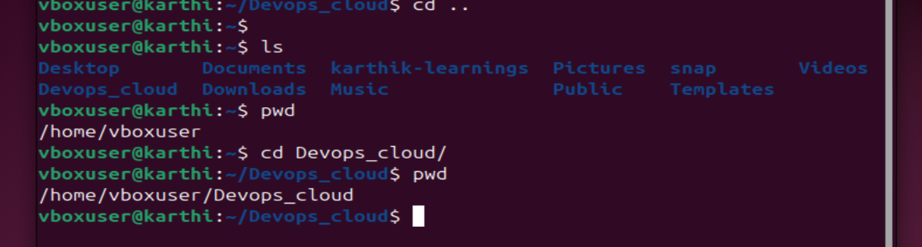

1. **Change the current directory .**



1. **Create a new empty file.**

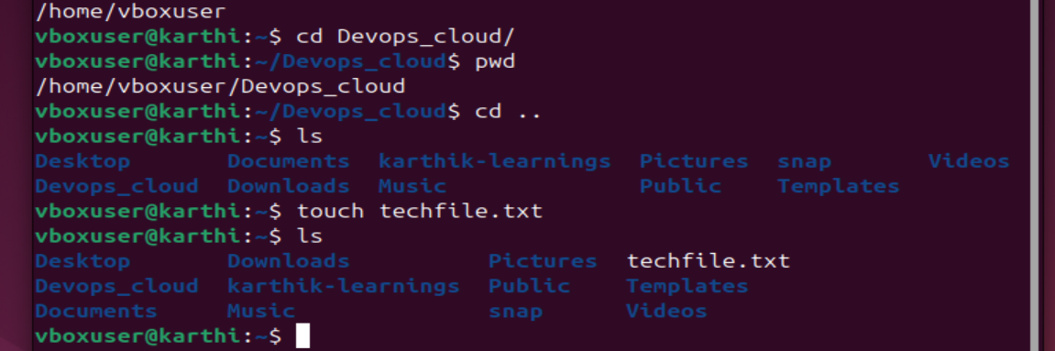

1. **View the contents of a file.**

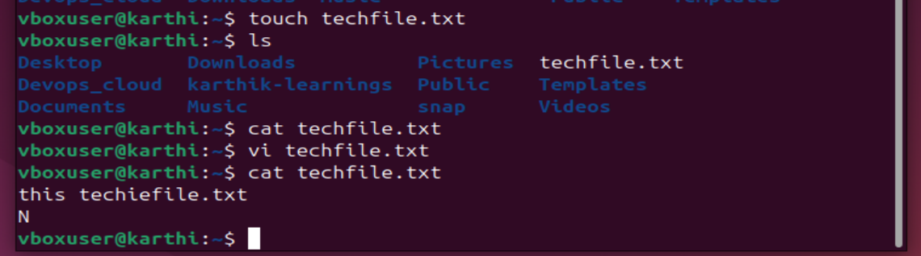

1. **Copy a file to another location.**

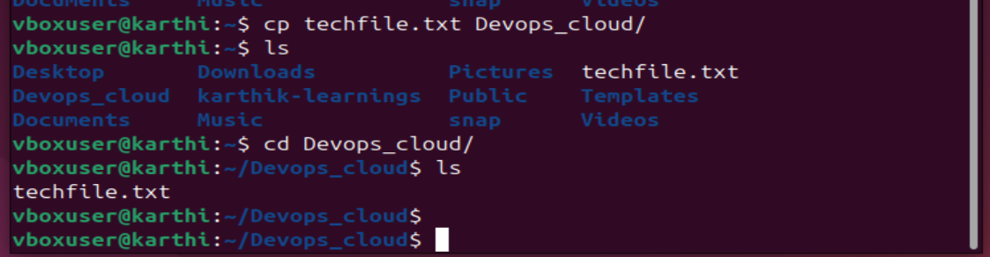

1. **Move a file to another location.**

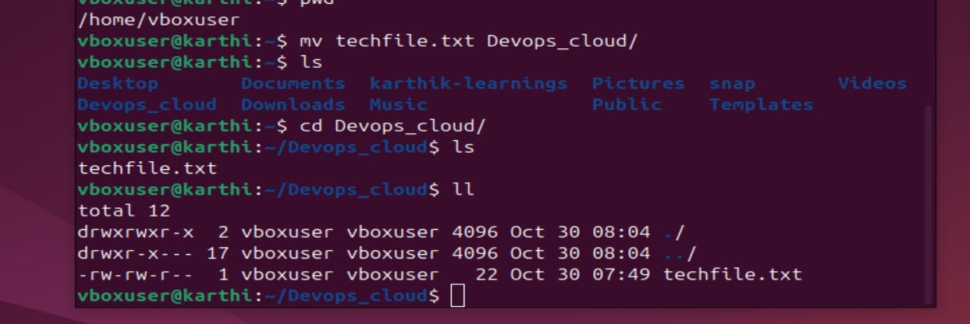

1. **Rename a file.**

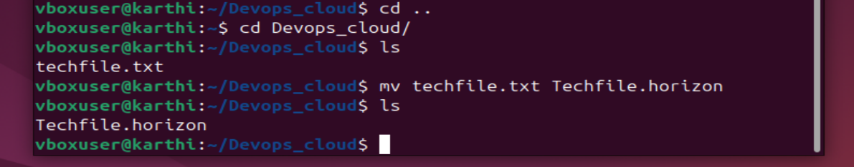

1. **Delete a file.** 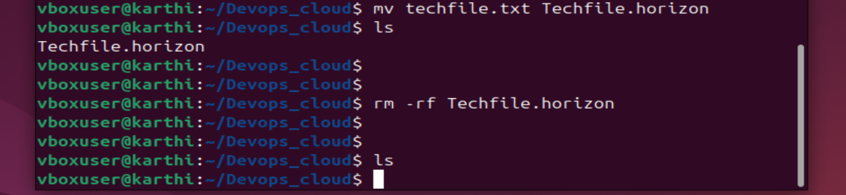
2. **Grant or revoke permissions on a file or directory.**

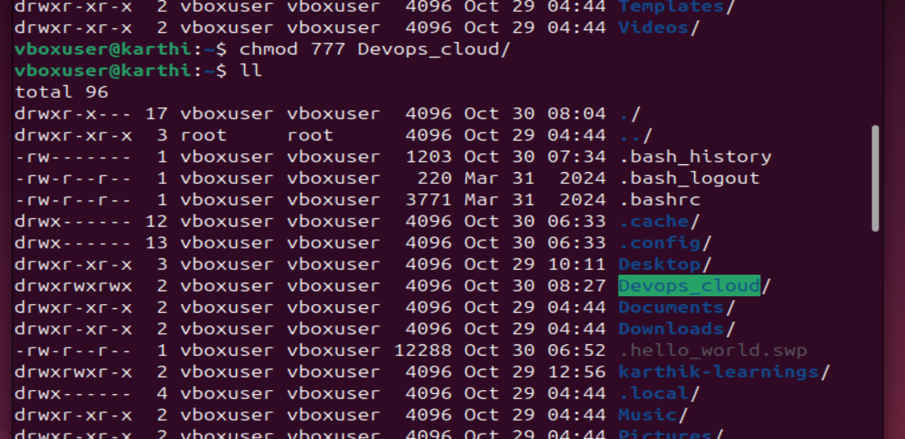

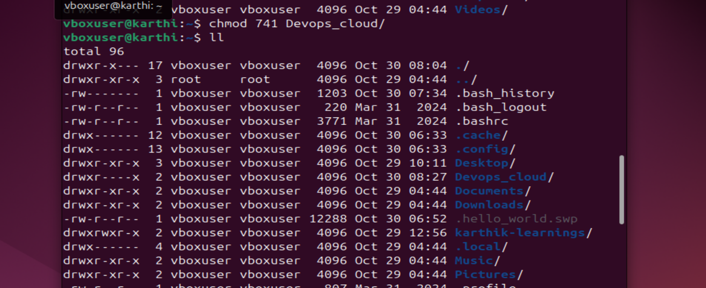

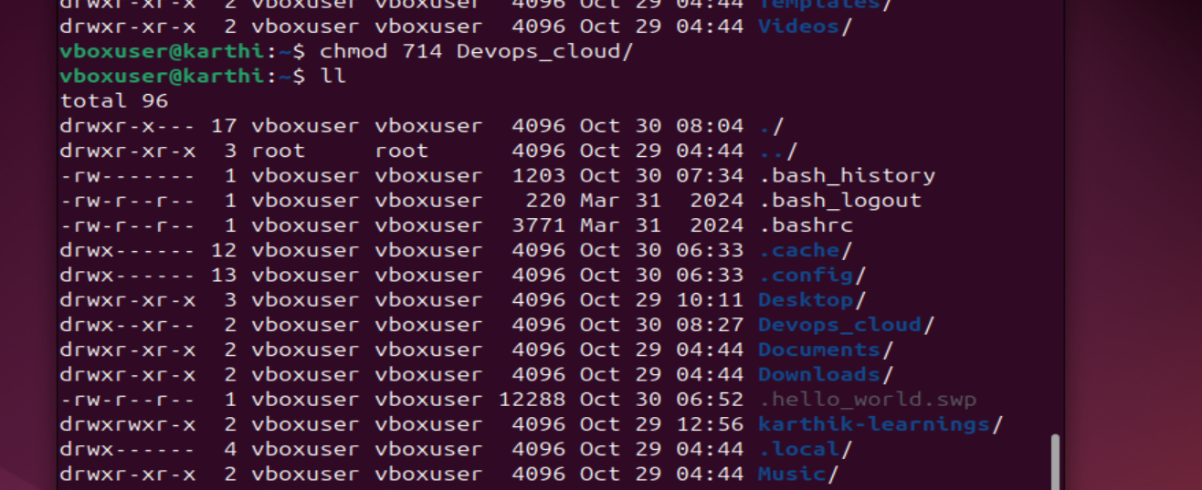

1. **View the current date and time.** 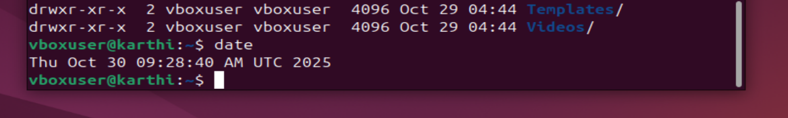
2. **Check the system uptime.** 
3. **View the running processes.** 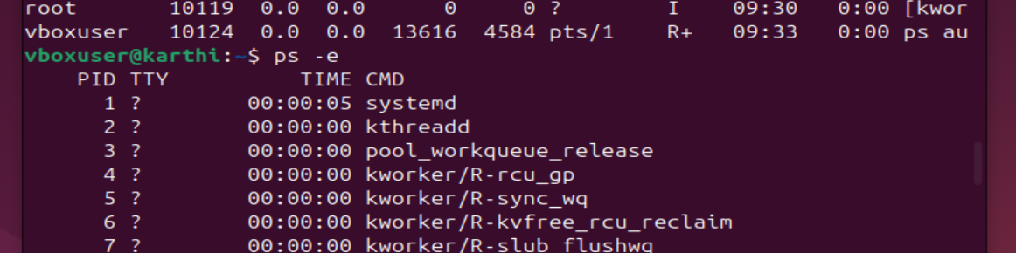 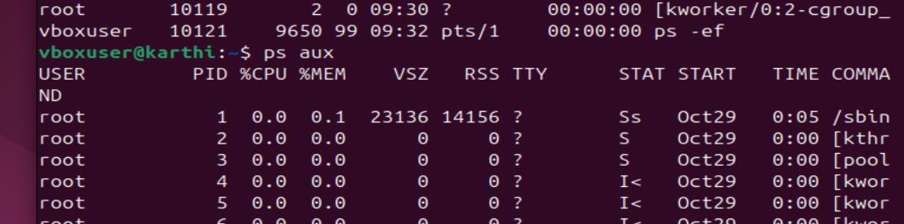 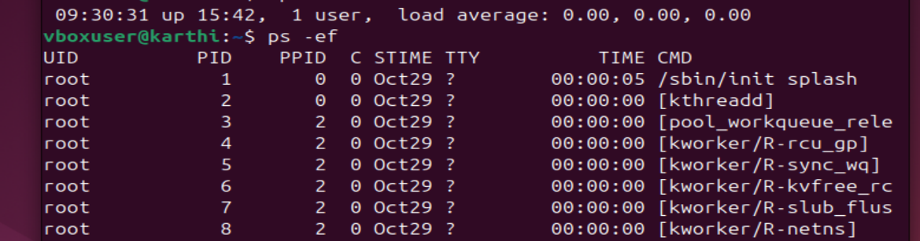
4. **Kill a running process.** ****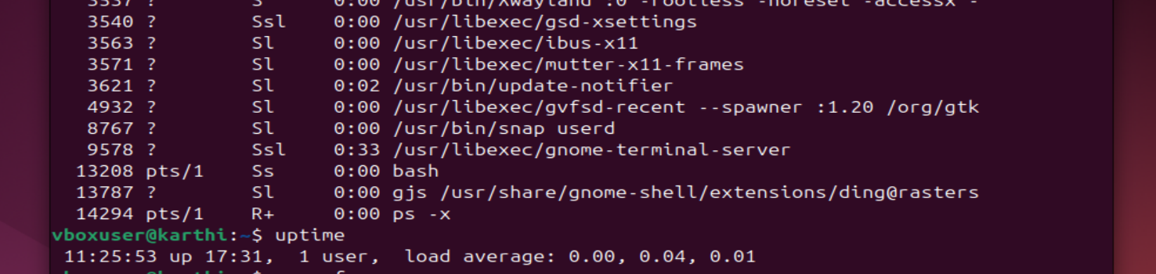
5. **Install a package using the package manager (e.g., apt or yum).**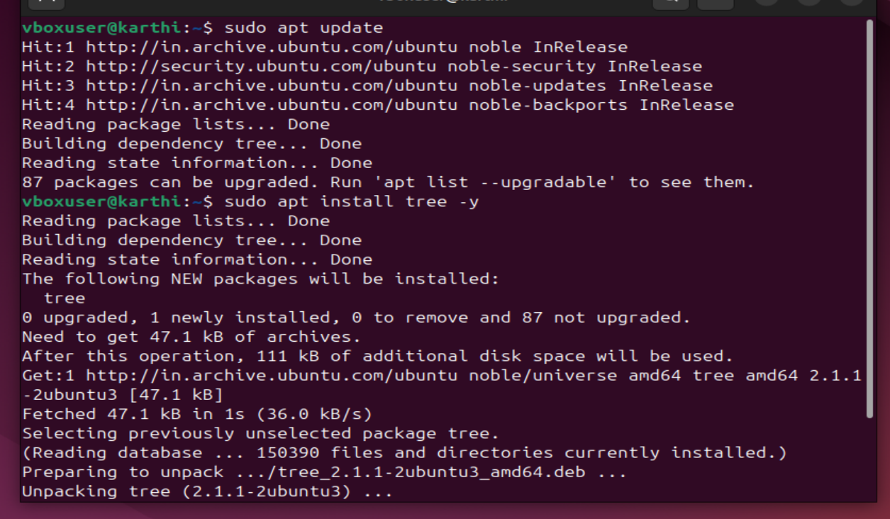
6. **Update the system packages.**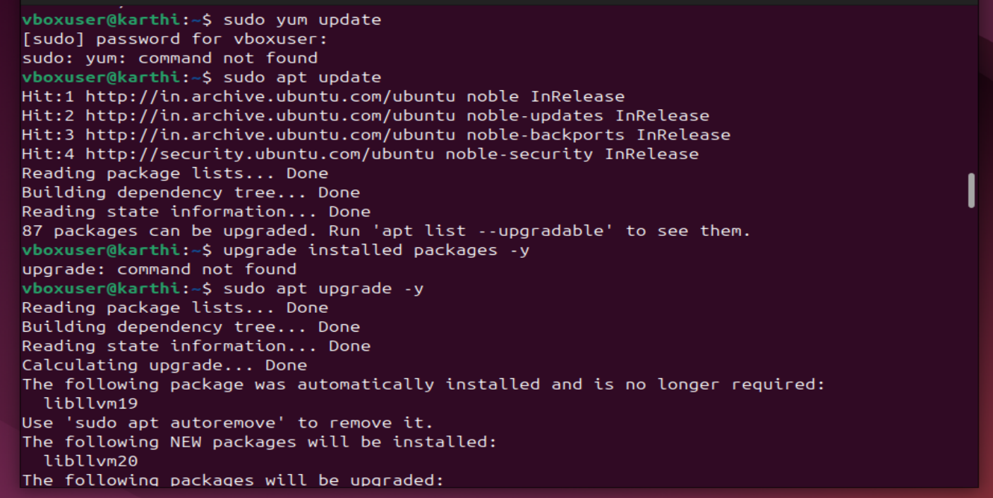

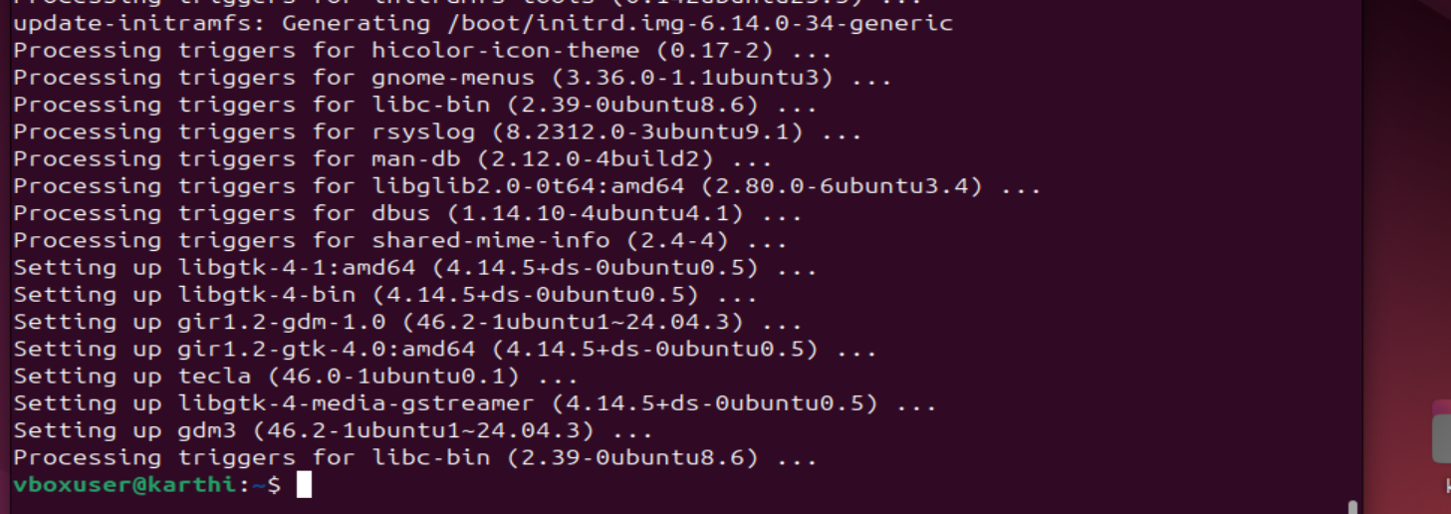

1. **Create a symbolic link.**

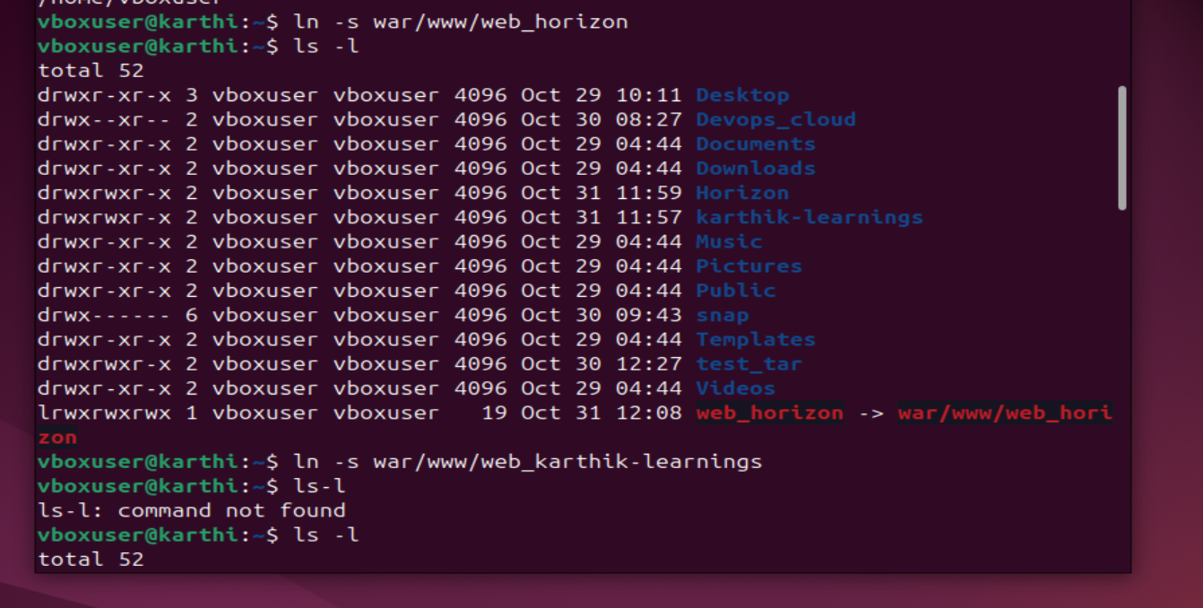

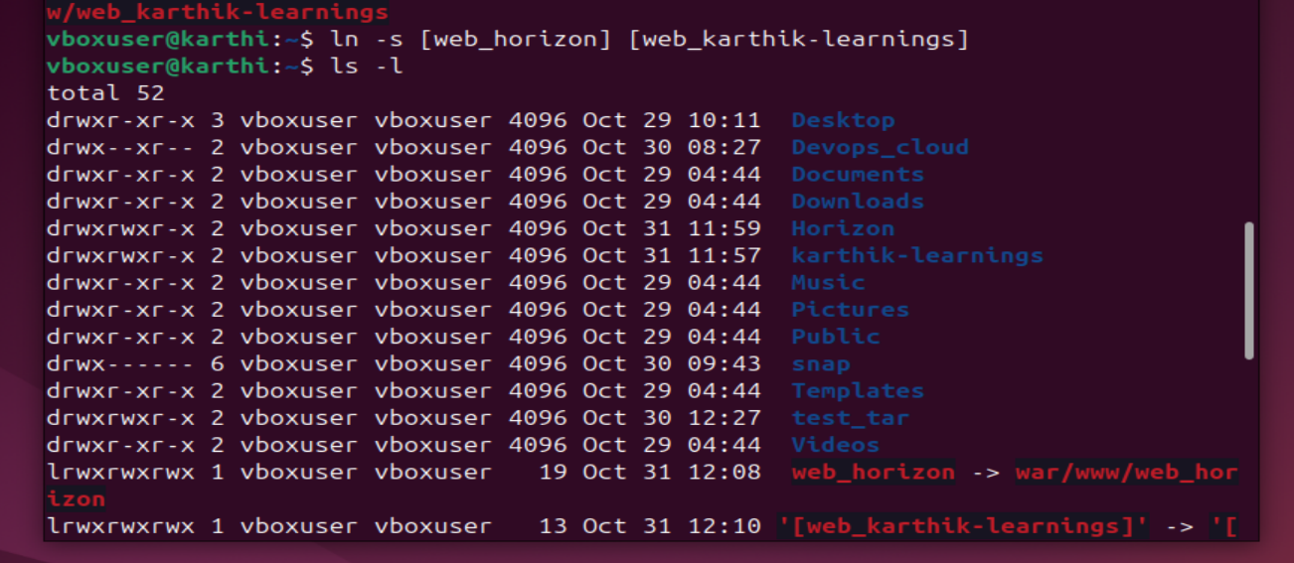

1. **Search for files using the find command.** 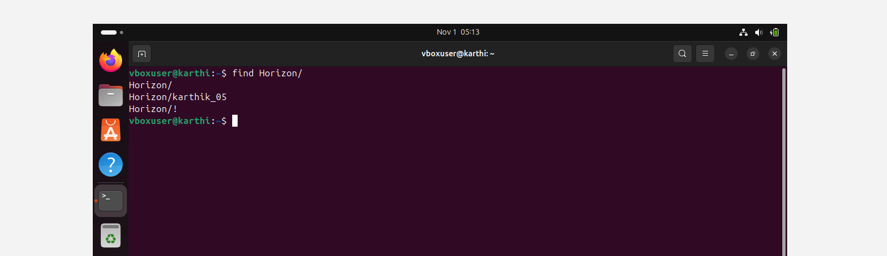

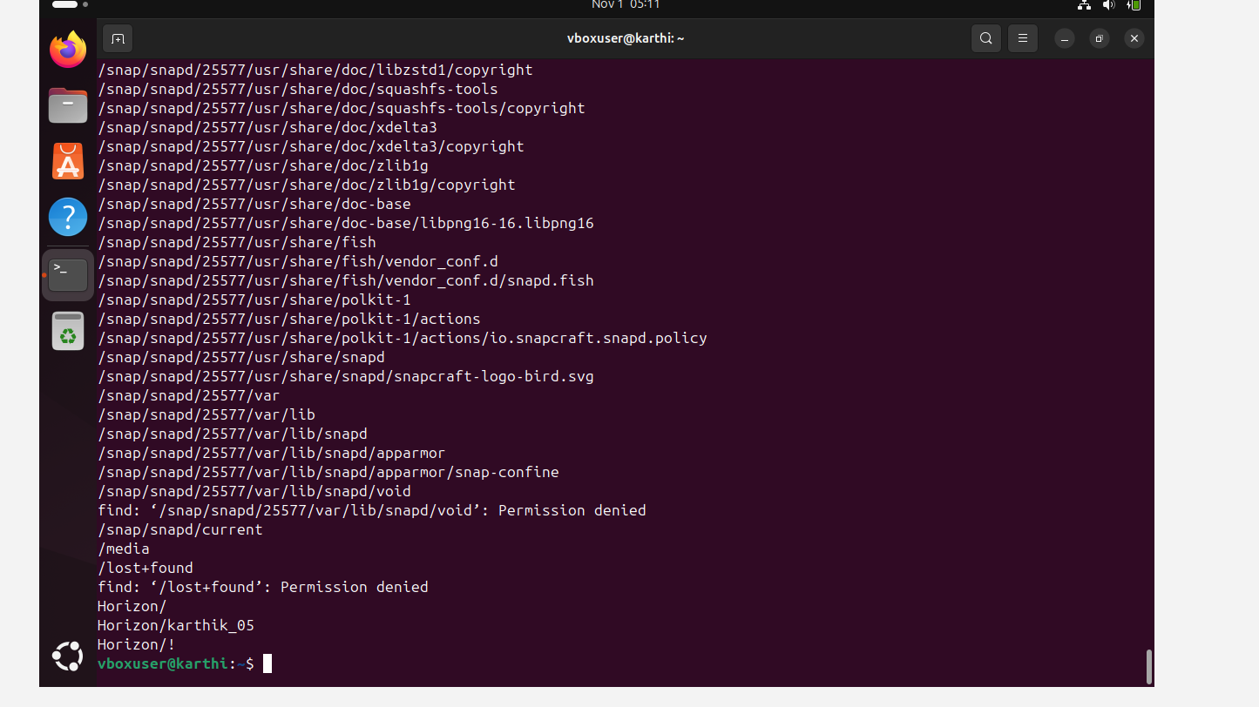

1. **.**



 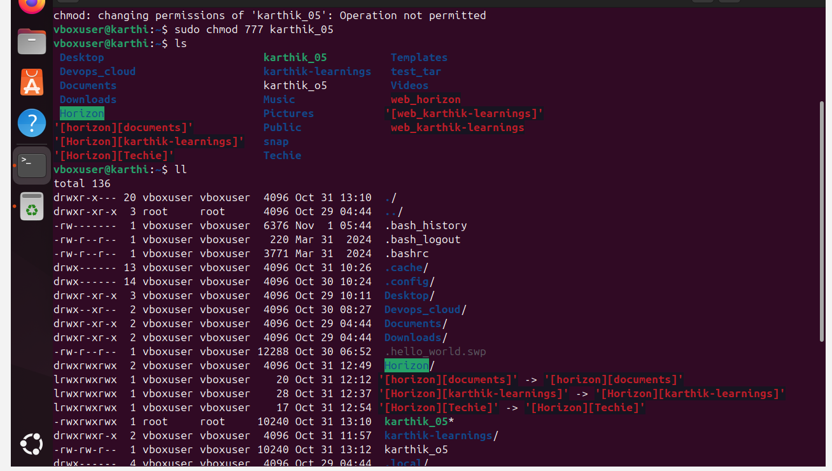

1. **Compress and decompress files using tar.**

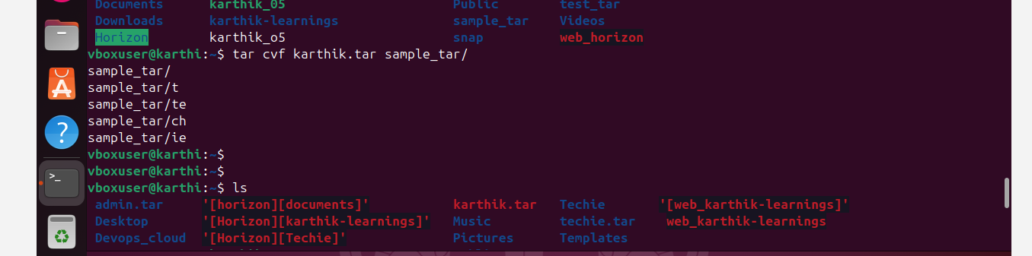 

1. **Monitor system resources with top or htop.**

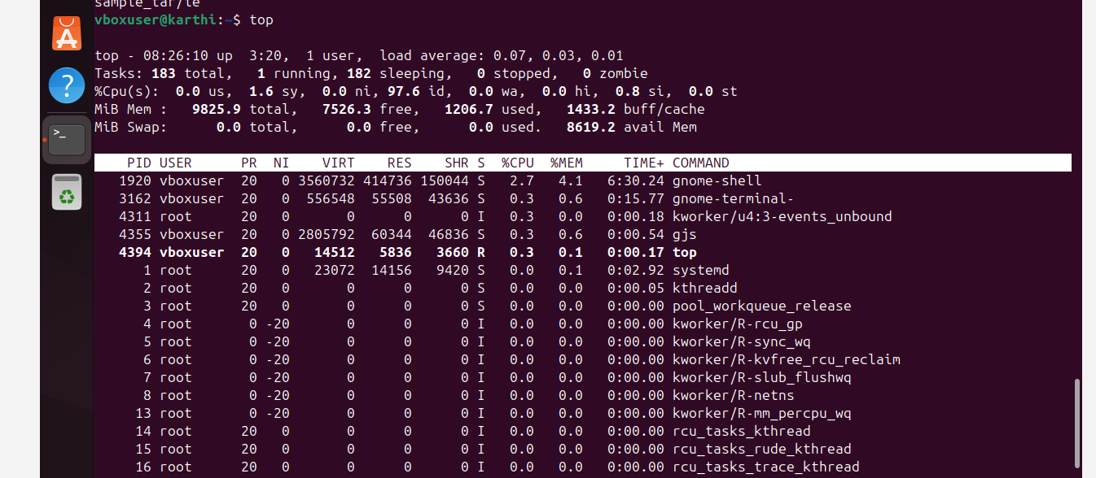

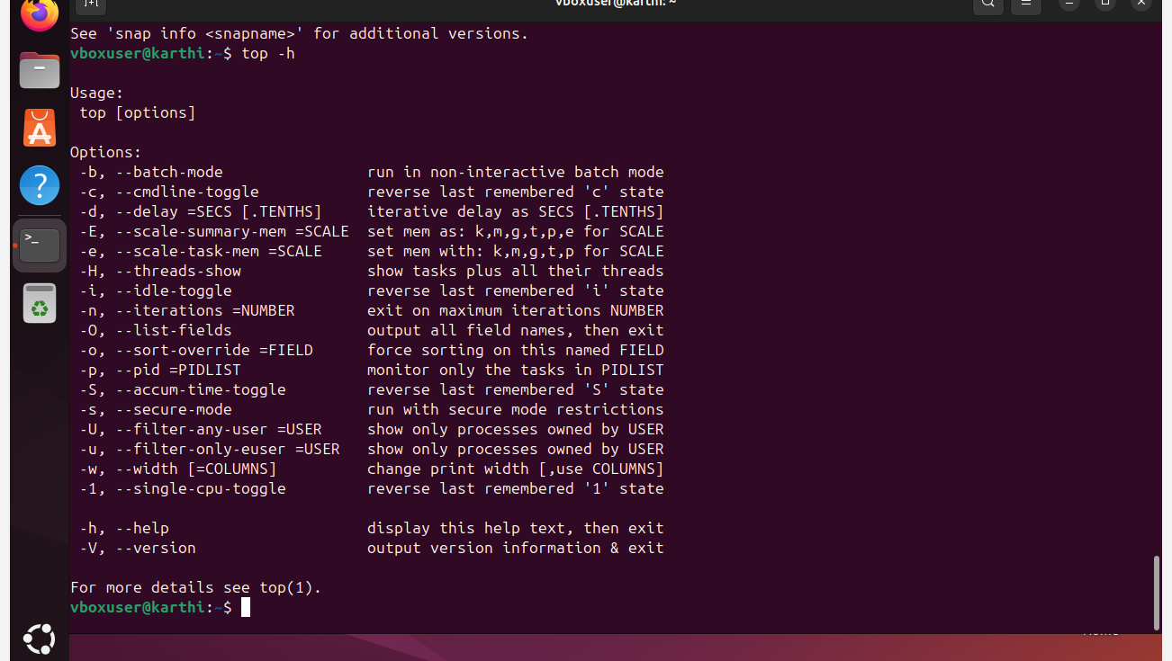

1. **Create and manage user groups.**

 

 



 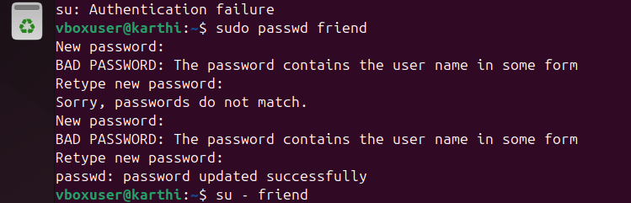  



1. **Set up SSH password less authentication.**

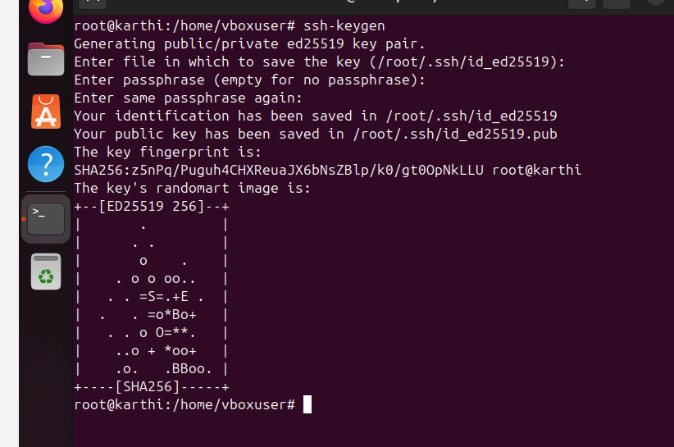

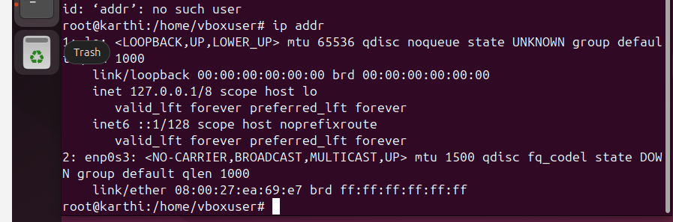

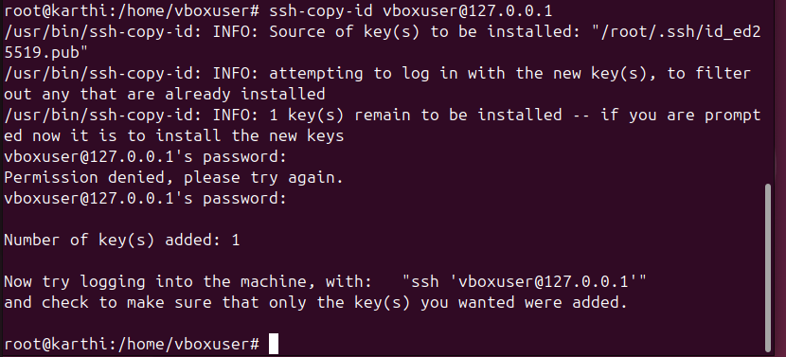

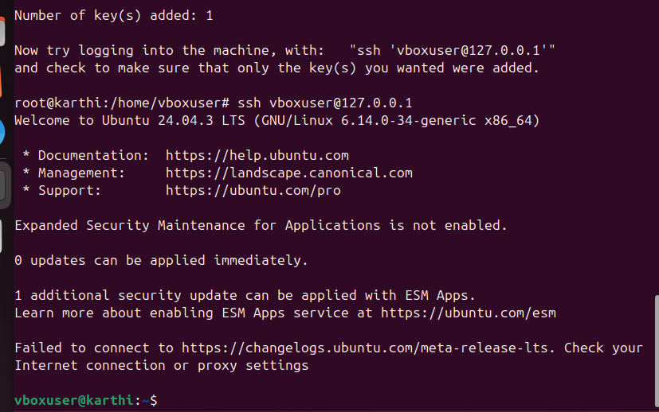

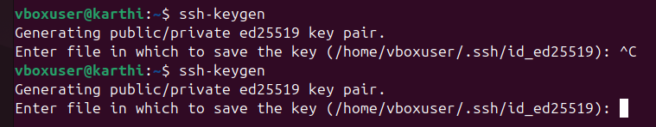

**26 . Monitor log files using tail or grep.**

**In summary, to monitor a log file, you need to know its full path so that tools like tail or grep can navigate to the correct location and**

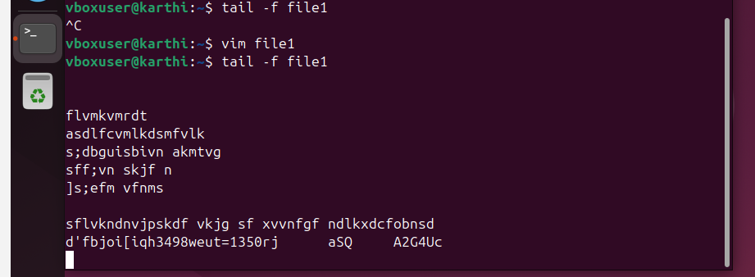

27 . **Set up a web server (e.g., Apache or Nginx).**

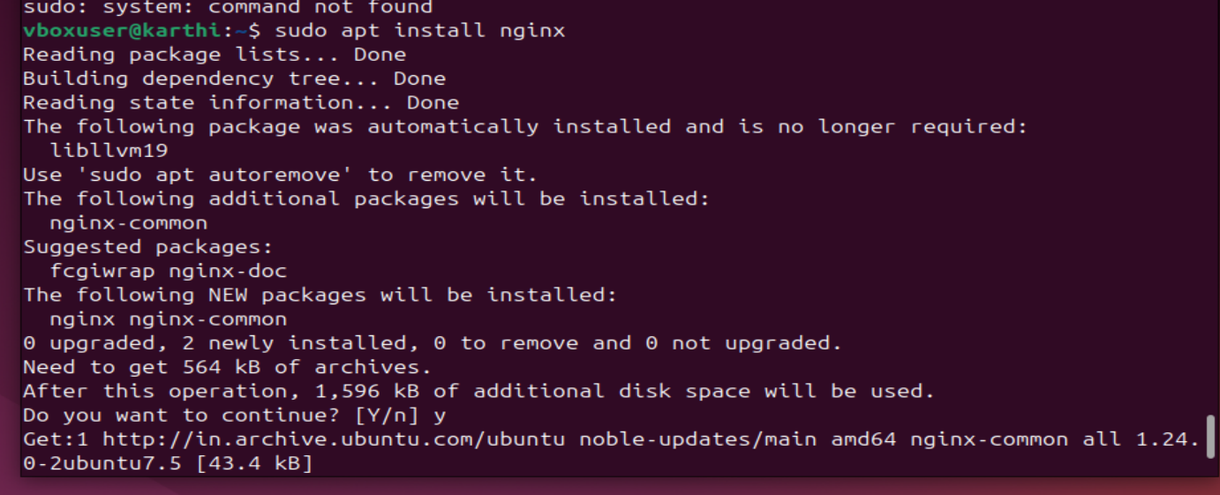

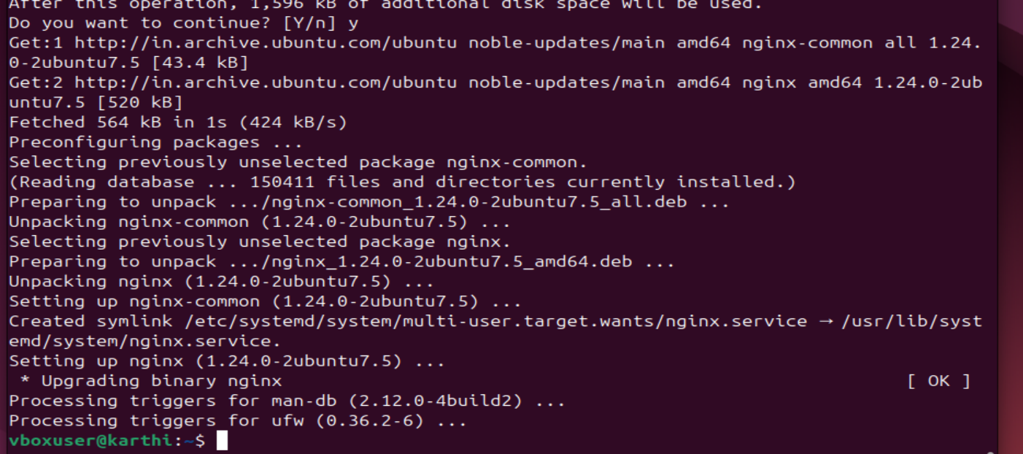

Apache9

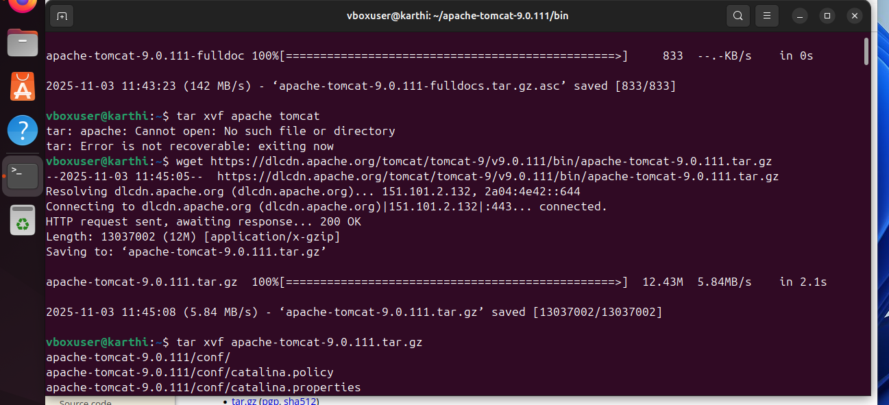

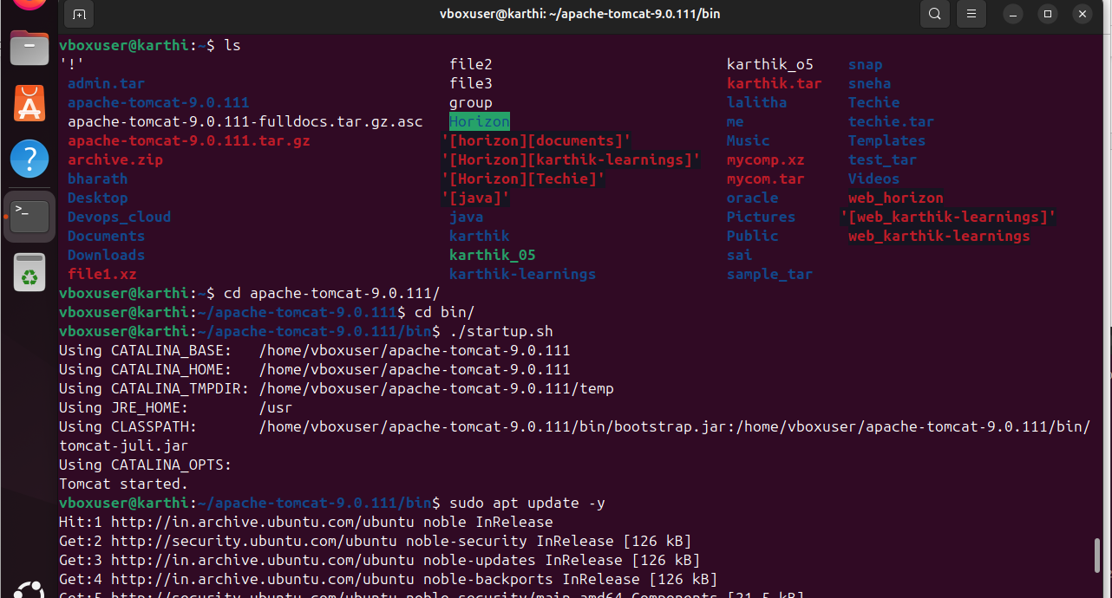

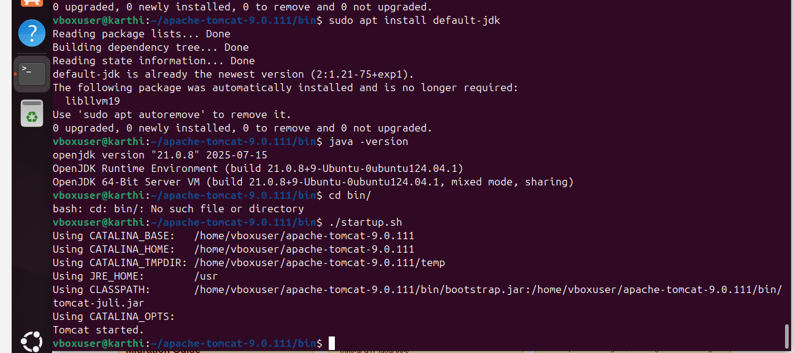

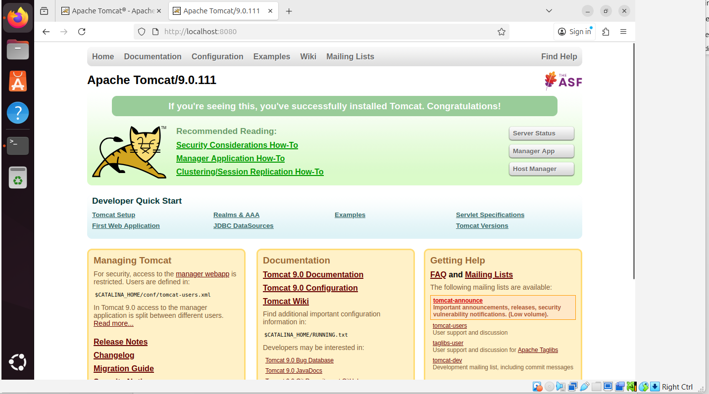

1. Configure and secure a MySQL Database.

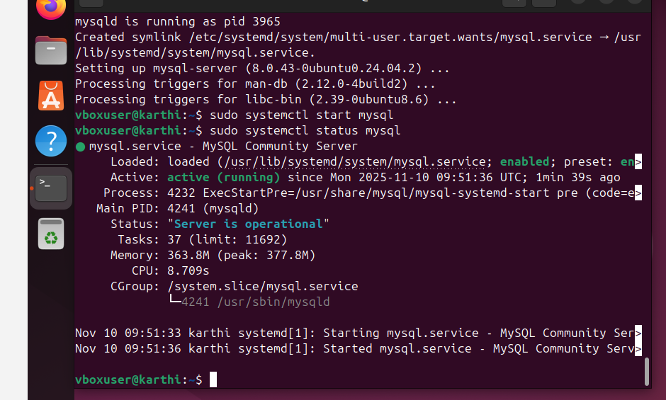

29. Set up a Application Server (e.g.,Apache Tomcat)

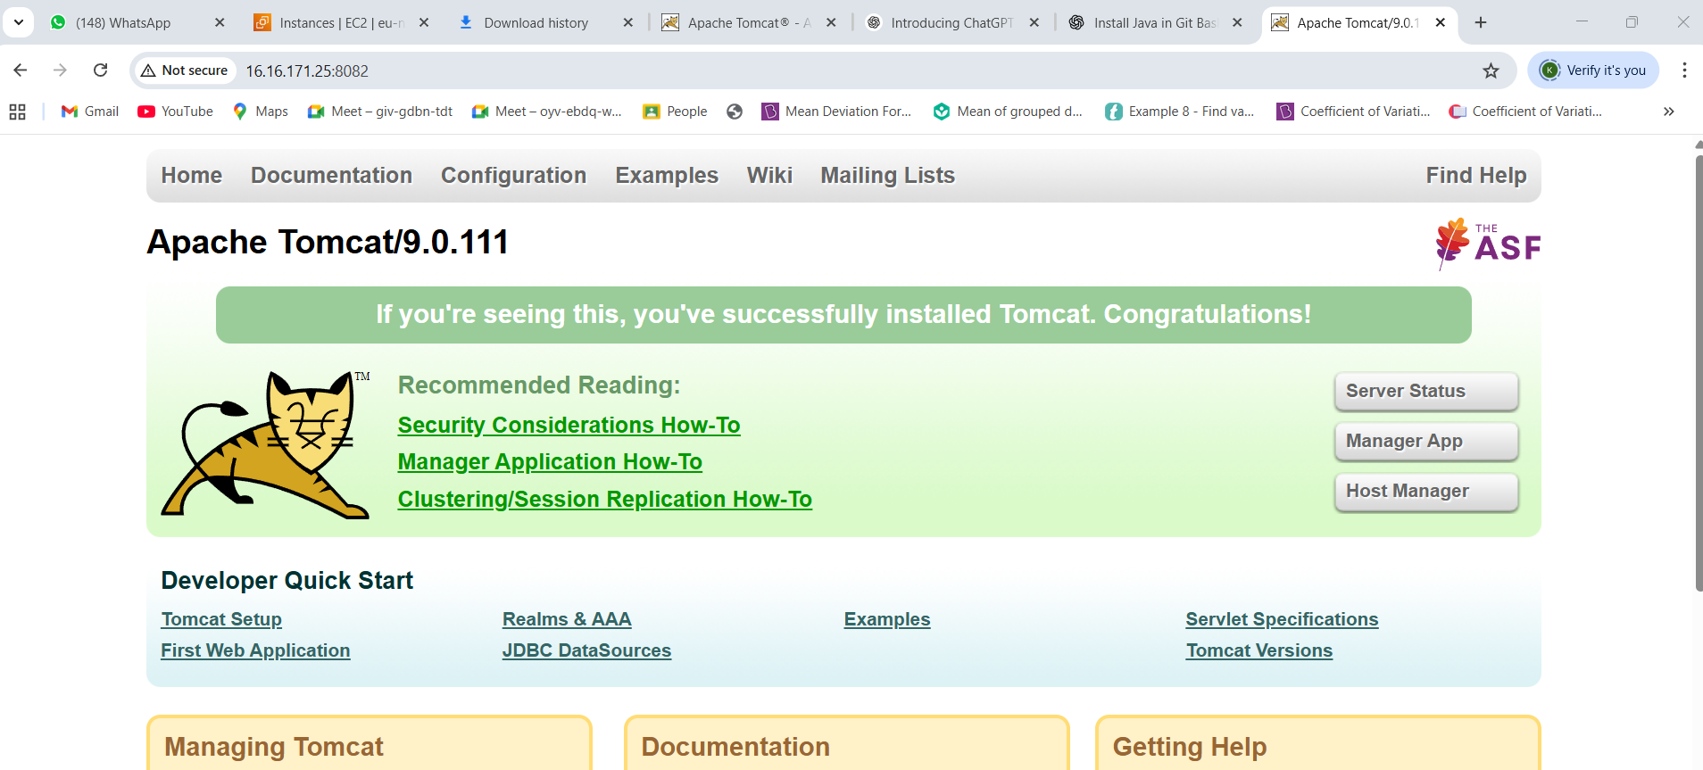

1. Print specific columns from a delimited file.

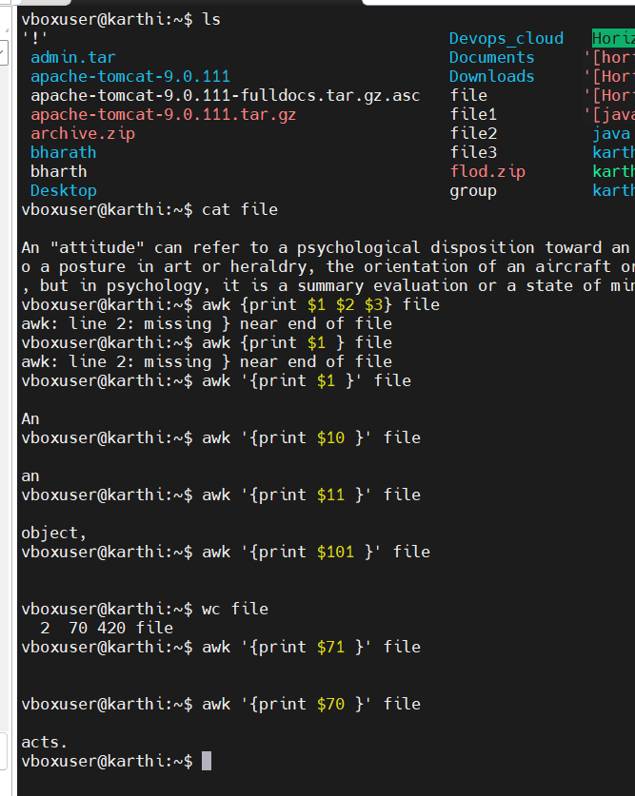

1. Filter and print lines based on a specific pattern or condition.



1. Calculate and print the average, sum, or other statistics of a column.
2. **Calculate and print the average, sum, or other statistics of a column.**

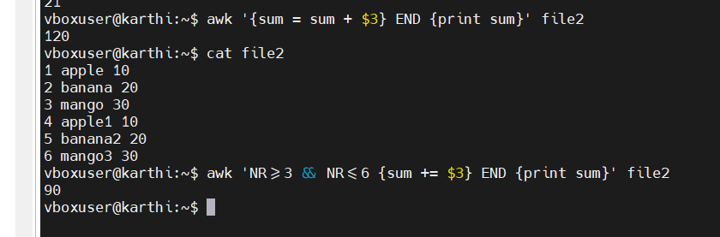**\**

1. Perform string manipulation, such as extracting substrings or changing case.

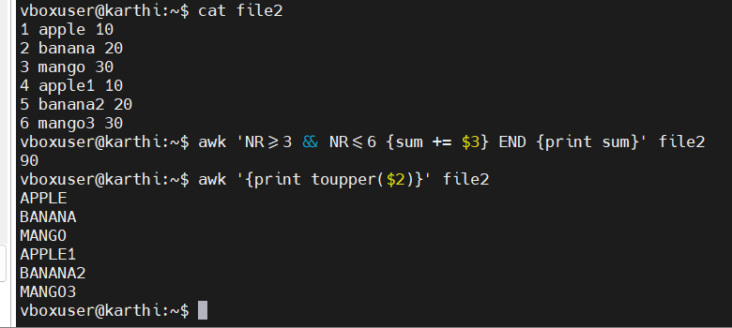

1. **Count the occurrences of a specific pattern in a file.**

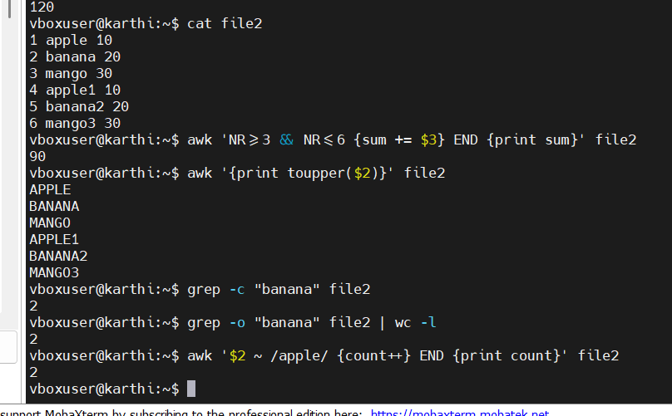

1. **Sort lines based on a specific field or column.**

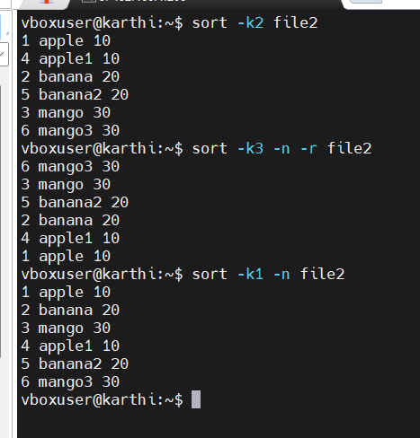

**34.Merge multiple files based on a common field or column**

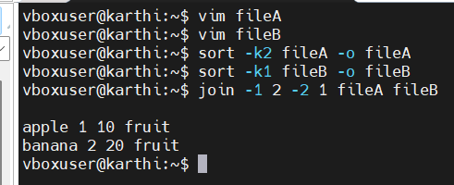

1. **Substitute text in a file using search and replace.**

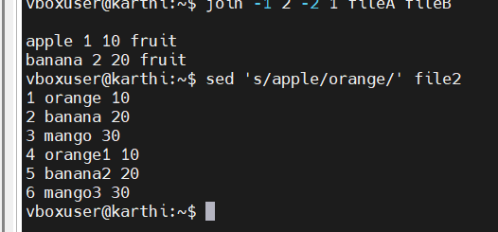

1. **Delete specific lines based on a pattern or line number.**

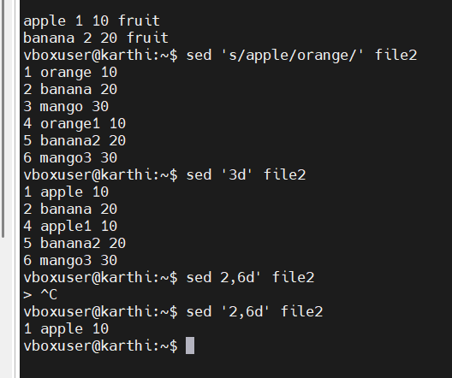

1. **.Append or insert text before or after a specific pattern or line.**

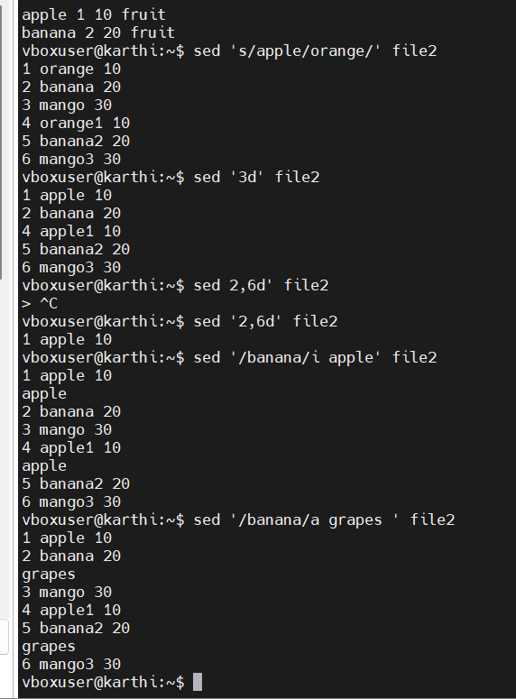

1. **Print only specific lines from a file.**

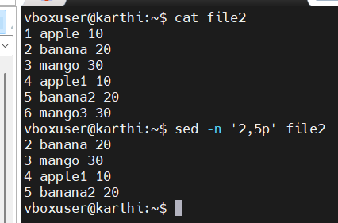

1. **Copy file from linux to windows machine**

scp file2 karthik@192.168.1.50:/mnt/c/Users/karthik/Desktop/

1. 5 use cases for AWK and 5 use cases for sed

